IRF22/2684

Gateway determination report – PP-2022-2692
Rezone land at Rileys Hill for village and environmental purposes (36 dwellings)
August 22

Published by NSW Department of Planning and Environment
dpe.nsw.gov.au
Title: Gateway determination report – PP-2022-2692
Subtitle: Rezone land at Rileys Hill for village and environmental purposes (36 dwellings)
© State of New South Wales through Department of Planning and Environment 2022. You may copy, distribute, display, download and otherwise freely deal with this publication for any purpose, provided that you attribute the Department of Planning and Environment as the owner. However, you must obtain permission if you wish to charge others for access to the publication (other than at cost); include the publication in advertising or a product for sale; modify the publication; or republish the publication on a website. You may freely link to the publication on a departmental website.
Disclaimer: The information contained in this publication is based on knowledge and understanding at the time of writing (August 22) and may not be accurate, current or complete. The State of New South Wales (including the NSW Department of Planning and Environment), the author and the publisher take no responsibility, and will accept no liability, for the accuracy, currency, reliability or correctness of any information included in the document (including material provided by third parties). Readers should make their own inquiries and rely on their own advice when making decisions related to material contained in this publication.

Acknowledgment of Country
The Department of Planning and Environment acknowledges the Traditional Owners and Custodians of the land on which we live and work and pays respect to Elders past, present and future.

Contents
1 Planning proposal 3
1.1 Overview 3
1.2 Objectives of planning proposal 3
1.3 Explanation of provisions 3
1.4 Site description and surrounding area 4
1.5 Mapping 5
1.6 Background 9
2 Need for the planning proposal 9
3 Strategic assessment 9
3.1 Regional Plan 9
3.2 Local 10
3.3 Section 9.1 Ministerial Directions 10
3.4 State environmental planning policies (SEPPs) 11
4 Site-specific assessment 11
4.1 Environmental 11
4.2 Social and economic 13
4.3 Infrastructure 13
5 Consultation 13
5.1 Community 13
5.2 Agencies 13
6 Timeframe 14
7 Local plan-making authority 14
8 Assessment summary 14
9 Recommendation 15

Table 1 Reports and plans supporting the proposal
Relevant reports and plans
Attachment A – Planning Proposal
Attachment B – Gateway Determination
Attachment C – Letter to Council
Attachment D - Gateway determination Report (20/01/2021)
Attachment E - Gateway determination (20/01/2021)
Attachment F – Termination Letter
Attachment G – Submission Report
Attachment H – BCD Agency consultation
Attachment I – Post exhibition changes (BCD recommendations)
Attachment J – Flood Study
Attachment K – BCD Comments
Attachment L – Department’s initial response to 2022 NSW Flood Inquiry and Criteria
Attachment M – Flood Advisory Panel Report

Planning proposal

Overview
Table 2 Planning proposal details
LGA | Richmond Valley
PPA | Richmond Valley Council
NAME | Rezoning of land at Hills Road, Rileys Hill from RU1 Primary Production to RU5 Village and C2 Environmental Conservation (36 homes)
NUMBER | PP-2022-2692
LEP TO BE AMENDED | Richmond Valley LEP 2012
ADDRESS | Hills Road, Riley Hill
DESCRIPTION | Lot 100 DP 1201719
RECEIVED | 27/07/2022
FILE NO. | IRF22/2684
POLITICAL DONATIONS | There are no donations or gifts to disclose and a political donation disclosure is not required
LOBBYIST CODE OF CONDUCT | There have been no meetings or communications with registered lobbyists with respect to this proposal

Objectives of planning proposal
The planning proposal contains objectives and intended outcomes that adequately explain the intent of the proposal.
The objectives of the planning proposal are to:
- rezone part of the land at Rileys Hill for village and environmental purposes;
- change the minimum lot size of the proposed RU5 Village land to facilitate low density residential lots;
- apply an appropriate minimum lot size to the C2 Environmental Conservation and retained RU1 Primary Production land that will prevent further subdivision and protect the environmental values of the land; and
- provide a single dwelling opportunity to the RU1 Zone residue area.
The objectives of this planning proposal are clear and adequate.

Explanation of provisions
The planning proposal seeks to amend the Richmond Valley LEP 2012 per the changes below:
Table 3 Current and proposed controls
Control | Current | Proposed
Zone | RU1 Primary Production | RU5 Village  C2 Environmental Conservation  Retained RU1 Primary Production
Minimum lot size | 40 hectares | 800m² (RU5 land)  4 hectares (C2 and retained RU1 land) to prevent further subdivision
Dwelling Opportunity | Nil | 1 (retained RU1 land)
Number of dwellings | Nil | 36
The planning proposal contains an explanation of provisions that adequately explains how the objectives of the proposal will be achieved.

Site description and surrounding area
The total area is 8.2 hectares in size and is located on the southern edge of Rileys Hill village.
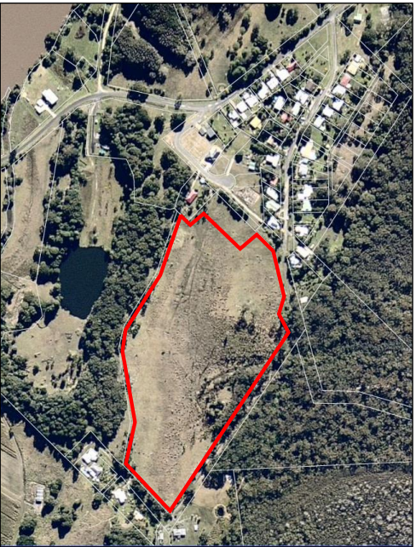
Figure 1: Subject Site (Source: 2021 Gateway determination report)
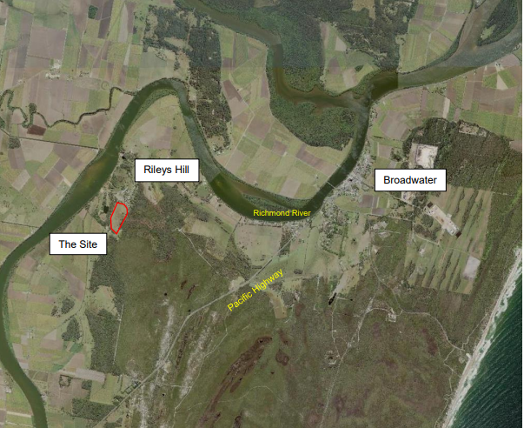
Figure 2: Locality Map (source: 2021 Gateway determination report)

Mapping
The planning proposal is accompanied by mapping (Figures 3-8) showing the proposed changes to the Land Zoning, Minimum Lot Size and Dwelling Opportunity maps, that are satisfactory for exhibition purposes. Mapping prepared in accordance with the Department’s standard technical requirements would need to be prepared should the proposal proceed to finalisation.

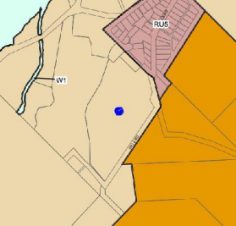
Figure 3: Current zoning map
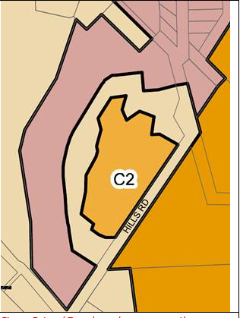
Figure 4: Proposed zoning map
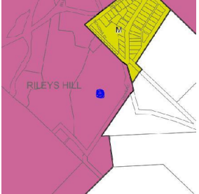
Figure 5: Current minimum lot size map
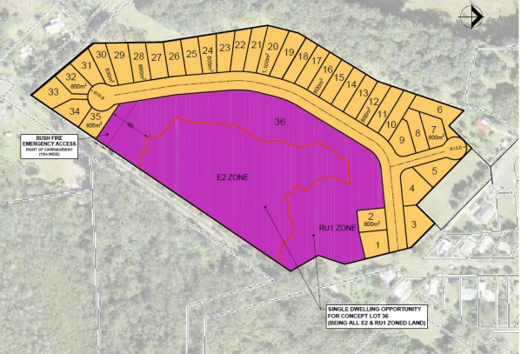
Figure 6: Proposed minimum lot size map

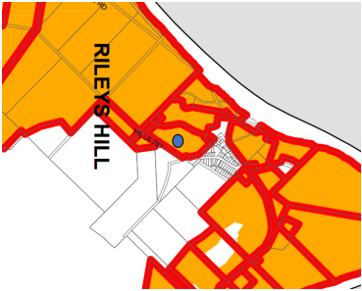
Figure 7: Current Dwelling opportunity Map

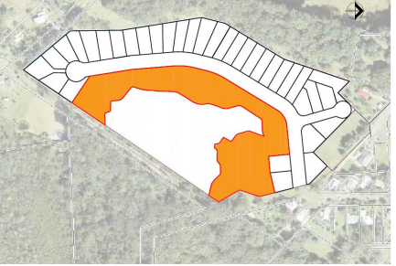
Figure 8: Proposed Dwelling Opportunity Map

Background
The proposal originally received a Gateway determination to proceed in 2018 but was terminated in 2020 due to the length of time that was being taken to finalise the rezoning.
The proposal was relodged and another Gateway determination to proceed was issued in January 2021 based on Council’s advice that progress to resolve the outstanding issues had been made. The proposal was exhibited and received agency objection from the NSW Biodiversity and Conservation Division (BCD) regarding the proposed extent and development potential of the proposed C2 zoned land. Various other issues were also raised in submissions that needed to be addressed by Council. Council requested the applicant to address the BCD and community submissions however no response was forthcoming for some period.
The Department encouraged Council to withdraw the planning proposal in May 2022. Council requested the period to complete the LEP be extended until the end of November 2022. Given the significant period since the initial Gateway determination was issued, and the nature of the outstanding issues associated with the proposal, the proposal was terminated again in June 2022.
Council has now resubmitted a revised proposal again for Gateway determination advised all outstanding matters including BCD’s previous objection have been resolved.

Need for the planning proposal
The land is identified as ‘Investigation area – urban land’ in the North Coast Regional Plan (NCRP) 2041 and the planning proposal was a result of a request from the landowner.
The planning proposal to rezone the land, change the minimum lot size and dwelling opportunity map is the only means of enabling the land to be developed for residential purposes.

Strategic assessment

Regional Plan
The subject land is identified in the North Coast Regional Plan (NCRP) 2041 as:
- within the identified urban growth area boundary; and
- an Investigation Area for urban land.
The planning proposal is generally consistent with the goals and actions of the NCRP 2041 except in relation to natural hazards as the land is flood prone and affected by the PMF event. As discussed below in further detail, the proposal’s inconsistency with this issue is unable to be resolved in the circumstances for the reasons outlined in the advice provided by the Department’s Flood Advisory Panel (Attachment M).

Local
The proposal is identified within Council’s Local Strategic Planning Statement (LSPS) as being an area of possible future urban growth for the village.
The proposal is also identified within Council’s Local Growth Management Strategy (LGMS), adopted by Council on 18 April 2023, as an investigation area for residential growth. The strategy identifies flood, stormwater, environmental and infrastructure constraints that would need to be addressed to support residential development. The LGMS has not yet been submitted to the Department for approval.

Section 9.1 Ministerial Directions

Direction 1.1 Implementation of Regional Plans

The proposal is considered to be inconsistent with the North Coast Regional Plan 2041 due flood risk and that this inconsistency is unable to be resolved in the circumstances for the reasons outlined in the advice provided by the Department’s Flood Advisory Panel (Attachment M). This is discussed further below in regard to flooding.
Direction 4.1 Flooding

The proposal is inconsistent with the Direction as it increases the development potential of the land which is partly below the 1% AEP flood event and almost wholly below the PMF event. It is considered that this inconsistency is unable to be resolved in the circumstances for the reasons outlined in the advice provided by the Department’s Flood Advisory Panel (Attachment M). This is discussed further below in regard to flooding.

Direction 4.2 Coastal Management

This Direction is relevant as the planning proposal affects land mapped as being partly within the coastal environment area under the State Environmental Planning Policy (Resilience and Hazards) 2021. Due to the nature of the land, the proposed zoning of the wetland area within the site to C2 and the retention of a RU1 buffer consistent with BCD advice, the surrounding land uses, and the existing controls in the Richmond Valley LEP 2012 regarding wetlands and riparian areas, the inconsistency with this Direction is considered to be of minor significance.

Direction 4.3 Planning for Bushfire Protection

The planning proposal is potentially inconsistent with this Direction as it applies to land that is bush fire prone. The Direction provides that the Council must consult with the Commissioner of the NSW Rural Fire Service (RFS) after a Gateway Determination is issued and before community consultation is undertaken. Until consultation has been undertaken, the Direction remains unresolved.

Direction 4.4 Remediation of Contaminated Land

A preliminary contaminated site investigation has been undertaken for the site. It concludes that the site has not been contaminated from historical land uses and is suitable for the proposed rezoning. It is considered the proposal is consistent with this Direction.

Direction 8.1 Mining, Petroleum Production and Extractive Industries

The Direction provides that a Relevant Planning Authority must consult with the Director General of the Department of Primary Industries to identify potential extractive industries in the vicinity of the proposal and take into account issues that may lead to land use conflict between the extractive industry and the proposed land use.

The subject land is located east of the Rileys Hill Quarry. Although not operational in the last 50 years, it is identified as a regionally significant armour rock quarry. The subject land is located within the transition area around the quarry.

A land use conflict risk assessment confirms that there has been no application or interest from any party to reactivate the quarry, and that given the time that had elapsed since the quarry has operated and the lack of interest in the intervening years, it is not envisaged that the quarry would ever recommence operations.

It is also noted that the existing Riley’s Hill village comprises residential dwellings to both the north-east and south-west of the subject site which are located within 500m of the former quarry. In addition, the vast bulk of the existing residential dwellings within the buffer to the quarry have been erected within the last 50 years.

Consultation with Division of Resources and Geoscience (the relevant authority now rather than NSW DPI) during the previous exhibition period confirmed they have no objection to the proposal proceeding. Re-consultation will be necessary in accordance with the Direction before the consistency of the proposal can be determined.

Direction 9.1 Rural Zones

The proposal is inconsistent with this Direction as it seeks to rezone land from a rural zone to a village zone. The inconsistency with the Direction is considered to be justified by the identification of the land in the Growth Area Boundary of the North Coast Regional Plan 2041.

Direction 9.2 Rural Lands

The proposal is inconsistent with this Direction as it will affect land within an existing rural zone and does not support all of the Direction’s requirements such as supporting farmers in exercising their right to farm. The inconsistency with the Direction is considered to be justified by the identification of the land in the Growth Area Boundary of the North Coast Regional Plan 2041.

State environmental planning policies (SEPPs)
The proposal is considered to be consistent with all relevant SEPP’s. The previous Gateway Report discusses this in more detail (Attachment D).

Site-specific assessment

Environmental
Biodiversity
Multiple ecological assessments have been undertaken for the site to ensure any potential impacts to vegetation can be minimised and to satisfy concerns raised by BCD during the previous proposals (Attachment H). Council have adjusted the C2 boundary post the previous exhibition to address BCD issues to include all areas of habitat for threatened species (Wallum Froglet) and retention of two known hollow bearing tress into the C2 zoned land (Attachment I).
Flooding
A flood study (Attachment J) has been prepared to support the proposal.
The flood study identifies:
- The land is considered to be rare low hazard extreme flood fringe;
- That some land filling will be required to parts of the site to ensure that it will be above the 1% AEP level of 5m AHD;
- Council’s DCP will ensure that minimum design floor levels for any future buildings will be 5.5m AHD to incorporate a 0.5 freeboard;
- Internal roads will be filled above 5m AHD to provide flood free access to other parts of the Riley Hill village in time of PMF events;
- That in a major 1%AEP event the area could be isolated for between 2 to 4 days;
- Due to the nature of flooding in the area, there will be a 12 hour ‘window’ for residents to evacuate before the only access road out of the area is affected by the 5%AEP event; and
- That in an event larger than 1%AEP, residents could evacuate and ‘shelter in place’ within areas of the existing village higher than the PMF.
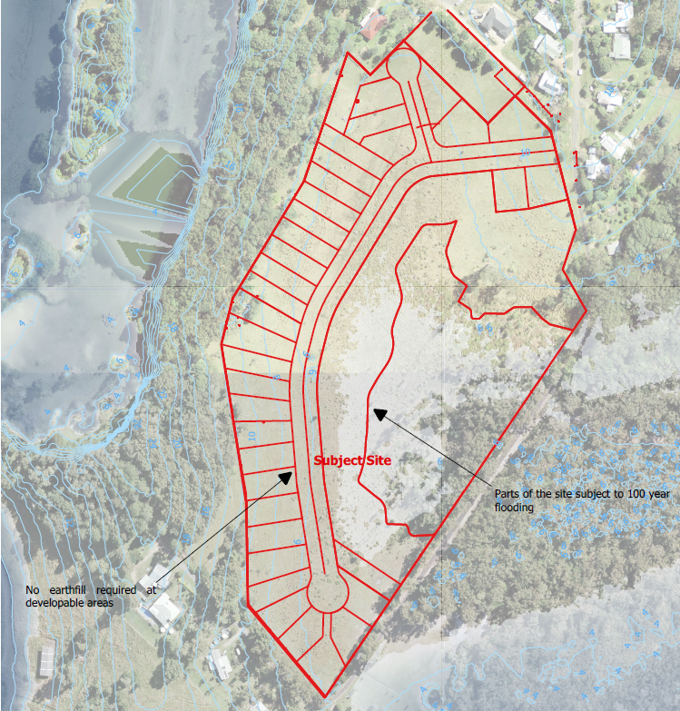
Figure 9: Proposed Flooding Map

The flood study has been reviewed by the BCD who provided advice that the proposal was satisfactory and could proceed (Attachment K).
The 2022 NSW Flood Inquiry recommends land be above the PMF with adequate evacuation routes. Additional comment from BCD was sought after the recommendations were made. BCD has re-iterated that its advice relating to flooding.
Filling of the site to achieve the PMF level (9.5m) is not considered appropriate in this instance due to the size and scale of filling that would be required and may also have implications for surrounding areas in the Rileys Hill locality.
Council has indicated that the decommissioned Rileys Hill school site which is used as de-facto community building may be an appropriate evacuation point and shelter in place location in the event of a PMF event. It is understood that this building would have no services or support staff in the event of a flood emergency.
Due to the 2022 NSW Flood Inquiry recommendations released in December 2022 (Attachment L), the proposal has been deemed ‘high risk’. On this basis the proposal was referred to the Department’s Flood Advisory Panel for consideration.
In consultation with the proponent, Council, SES, Infrastructure NSW (INSW), Transport for NSW (TFNSW), the Department’s Flood Technical Advisory Group (TAG) and Northern Region team, the Flood Advisory Panel provided the following advice (Attachment M):
Flood Impact Assessment
- The Panel agrees with the TAG and the state agencies that the Flood Report accompanying the Planning Proposal is outdated, relying on a regional Council Flood Study in place of site-specific flood modelling.
- The information provided does not include a full range of flood events (e.g. the 0.02% AEP), hazard mapping, adequate consideration of climate change, or modelling of the displacement of flood water from using fill.
- Consequently, the flood impacts to a highly flood prone site are underestimated and are likely to worsen once accurately known.
Evacuation
- During a range of flood events residents will be required to shelter in place for excessive periods, which will likely significantly increase the risk to life. The Panel agrees with the TAG and SES that the public are generally unprepared for sheltering in place for extended periods of time.
- The Panel notes that Rileys Hill can become isolated for days to weeks during extreme flood events and becomes cut-off during flood events as frequent as 20% AEP. Information provided by SES on the experience of residents in the recent 2022 Floods demonstrates that the existing Rileys Hill village required substantial assistance during that flooding emergency.
- The Panel notes that the Planning Proposal may result in an increase in the Rileys Hill population of approximately 91 additional residents (a potential 50% increase in population), further exacerbating the need for additional assistance during flood emergency.
- The Panel agrees with the TAG and SES that offsite evacuation is generally not feasible and will likely increase the risk to life. SES noted that there is no feasible evacuation point for residents of Rileys Hill and no safe evacuation route is available during flood events.
- PLUS and TAG also noted that the likely evacuation points at Broadwater or Woodburn are located lower in the floodplain and are themselves flood prone. The Panel notes the Flood Inquiry found that future development should not proceed where satisfactory arrangements for evacuation cannot be implemented (Recommendation 21).
Mitigation Options
- The Panel agrees with INSW that given the Site is highly flood prone, there are unlikely to be mitigation measures that will resolve the key evacuation constraints (i.e. rapidly inundated access roads and flood prone evacuation points) and risks associated with sheltering in place. Additionally, the Panel agrees with the SES, which notes the extent of works required to raise evacuation routes surrounding Rileys Hill out of the floodplain is prohibitive.
- Regarding a potential local flood refuge, no commitment has been made by Council or the Proponent to provide the required upgrades to community facilities to ensure a purpose-built evacuation centre is available to residents during extreme flood events.
Strategic Need
- The Panel acknowledges the Planning Proposal is an investigation area for future urban growth in the Richmond Valley Growth Management Strategy and the Richmond Valley Local Strategic Planning Statement (see section 2.2). The Panel also acknowledge the Site has been under consideration since early 2017. However, during the intervening time environmental, infrastructure, and flooding constraints have been identified.
- While the Site has been identified as having some strategic merit (see section 2.2), the Panel is mindful that there are other housing supply opportunities elsewhere in the Richmond Valley LGA. The Panel is aware that proposed development surrounding Casino is relatively unconstrained in comparison to the Site and has the capacity to meet the projected growth targets for the LGA.
- Consequently, the Panel considers there is no current strategic need for the Site from a regional housing supply perspective, given the ample capacity to meet housing targets provided by less constrained land fringing Casino, which is identified in local and state strategic planning documents.
Other Constraints
- The Panel notes that the development potential in Rileys Hill is currently limited due to the capacity of the Rileys Hill STP. The Panel also note that the development potential would be further reduced if the Rileys Hill STP were to be decommissioned and sewage services shifted from Rileys Hill to Evans Head as indicated by Council.
For the above reasons, the Panel is of the view that, on the basis of unacceptable flood-related impacts and limited evacuation capacity, the proposal be refused and not proceed past Gateway
In the circumstances with all the proposed dwellings being affected by the PMF, no flood free evacuation to an area with suitable support services and facilities being available, sheltering in place not a viable option, and the recommendation from the Flood Advisory Panel, it is considered that the current proposal is not appropriate at the present time due to flooding issues.

Social and economic
The proposal is expected to have positive economic and social outcomes with providing additional housing opportunities in Rileys Hill and with the multiplier effect associated with increased population is also expected to benefit businesses in the vicinity of the Rileys Hill village.

Infrastructure
The previous Gateway report discusses the infrastructure needs of the proposal (Attachment D). It was identified that there is sufficient road access and capacity relating to sewerage and water supply. It is noted that the Riley’s Hill Sewerage Treatment Plant (STP) may need further upgrades to support the increase from the residential development and that Council would need to address this issue further should the proposal proceed.

Assessment summary
While the proposal has a level of strategic merit due to its identification for potential future urban development in the North Coast Regional Plan and Council’s local Plans, it is considered that it should not proceed due to unacceptably high flood risks and impacts, the inability to evacuate safely, lack of feasible mitigation options, and the lack of strategic planning need.

Recommendation
It is recommended the delegate of the Minister determine that the planning proposal should not proceed because of:
- unacceptably high flood risks and impacts, the inability to evacuate safely, lack of feasible mitigation options, and the lack of strategic planning need.

8/6/23
_____________________________ (Signature) _______________________ (Date)
Craig Diss
Manager, Local and Regional Planning, Northern Region

14/6/2023
_____________________________ (Signature) _______________________ (Date)
Jeremy Gray
Director, Northern Region

Assessment officer
Jenny Johnson
Planning Officer, Northern Region
6643 6414

